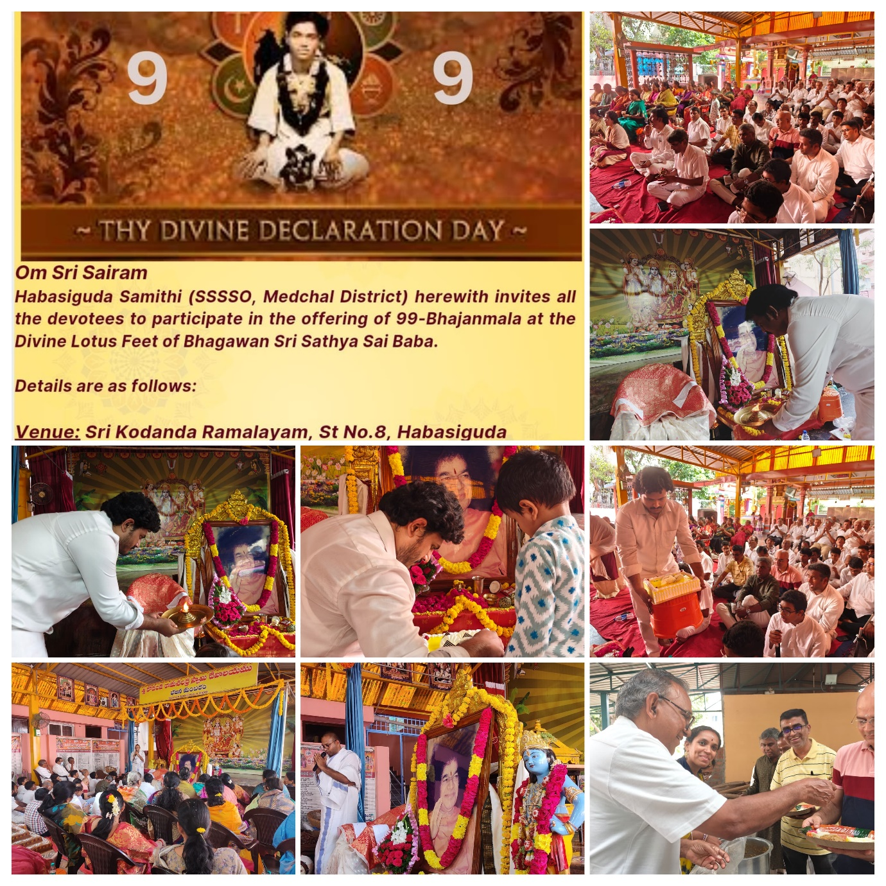I had an opportunity to share my thoughts in regard to the Song we offered at the divine feet of Bhagwan Sri Sathya Sai Baba varu in the year 1998.