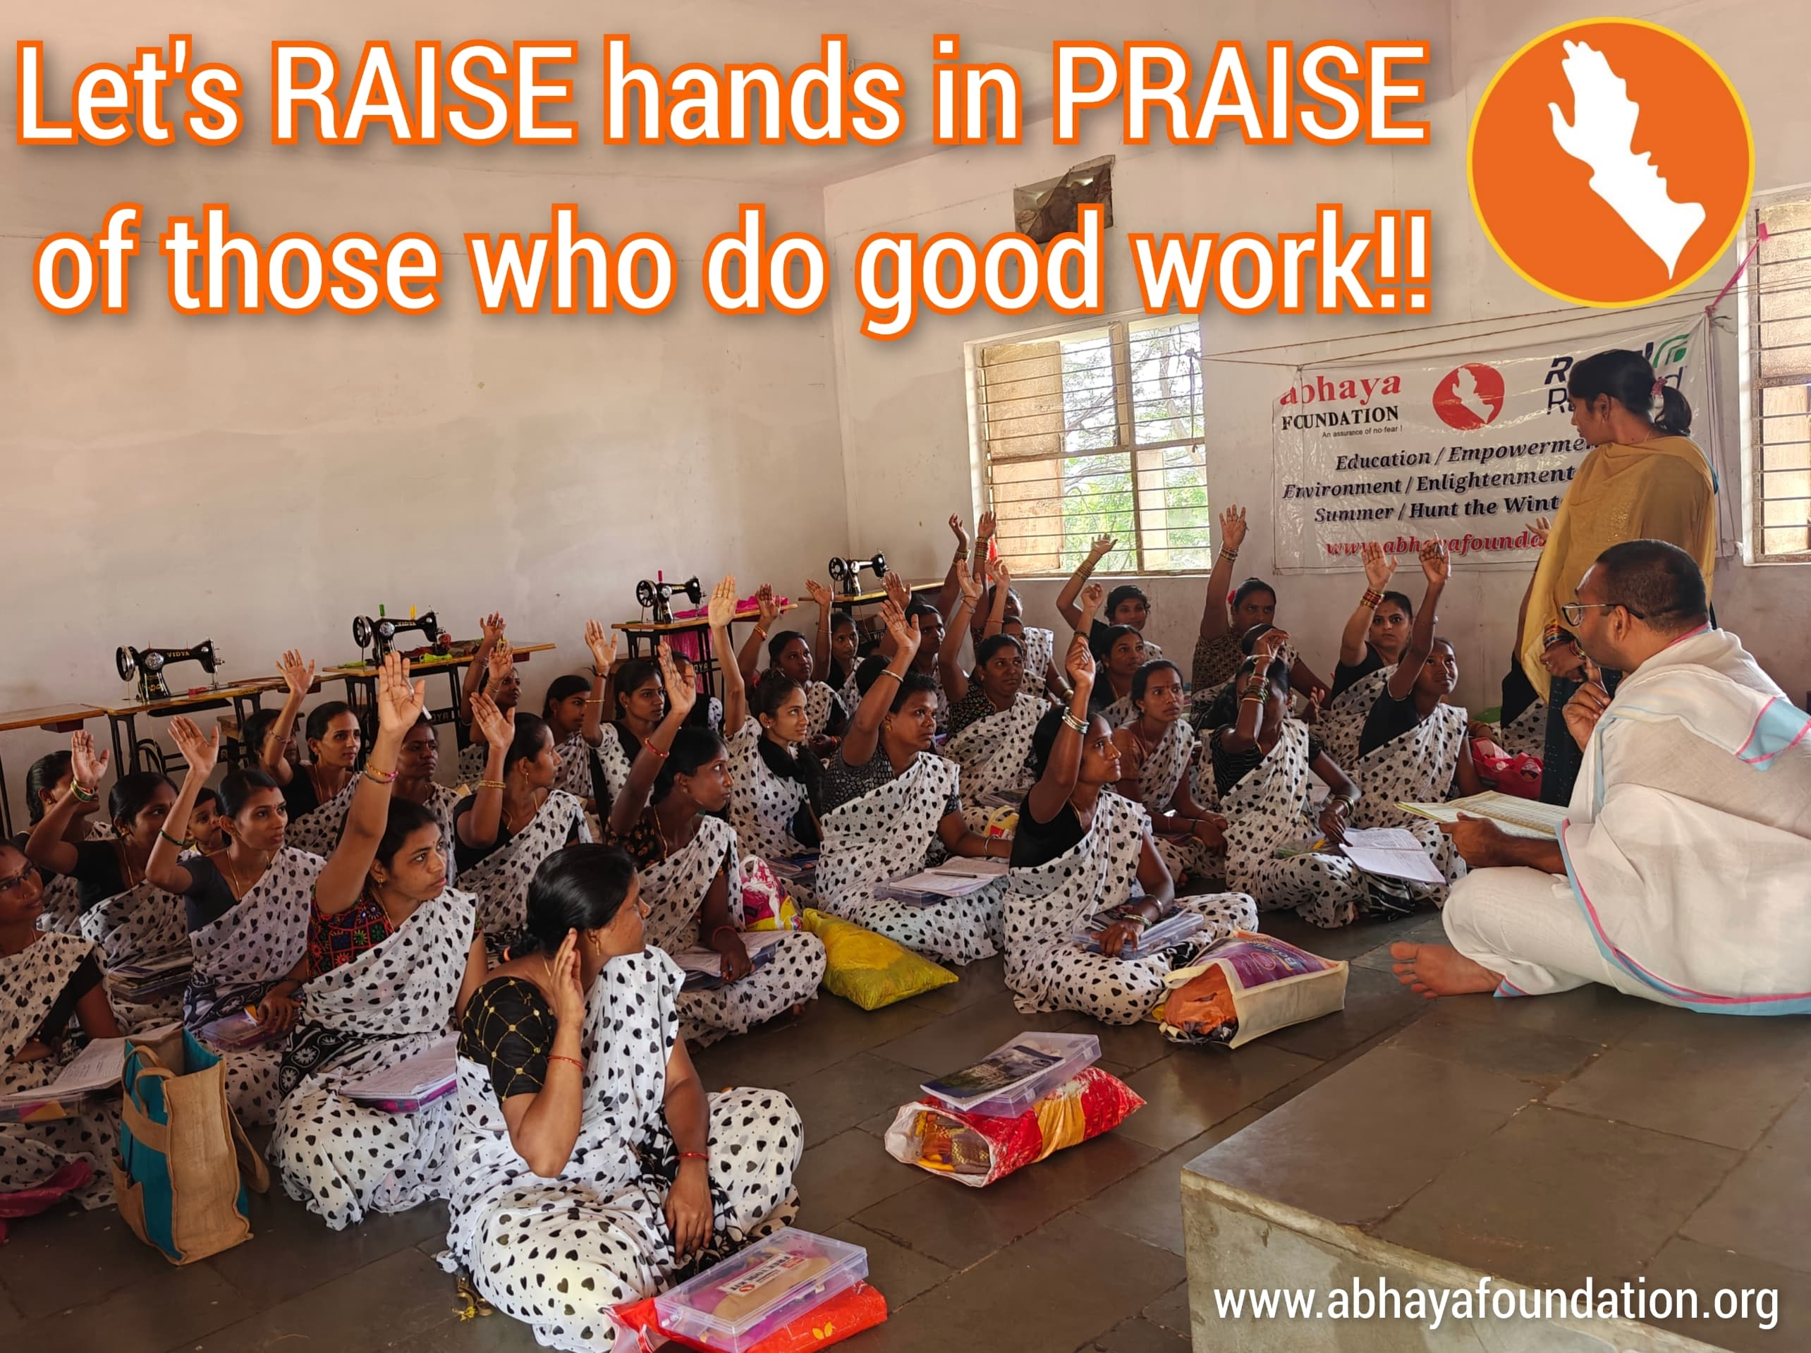

Sunday Thoughts: Let's RAISE hands in PRAISE of those who do good work!! Dear friends, let's cultivate a culture of gratitude and appreciation. Recognizing and celebrating the good deeds of others inspires kindness, encourages selflessness, and fosters a positive community. Let's share our appreciation with someone today! Let's spread the positivity and inspire kindness. - Balachandra

#SundayThoughts #Appreciation #Gratitude #PositiveVibes #KindnessMatters #InspireOthers

#abhayafoundation #InspirationalQuotes