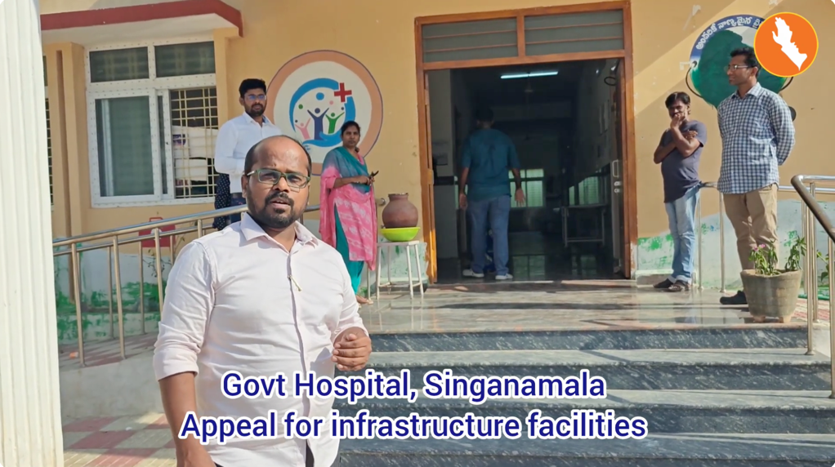

Regal Rexnord to support Govt Hospital, Singanamala

https://youtu.be/0m6zQUfJGt0?feature=shared

